First part: Interface method and parameters
- Get equipment operation information
TCHAR* getDevInfo(TCHAR* devSN,TCHAR* ip,int port,TCHAR* password,TCHAR* info)
Parameters devSN: device SN; ip: IP address; port: IP port number; password: device password; info: return value;
C#:cl2.getDevInfo(string, string, int, string, string);

- Get event record
int getRecord(TCHAR* devSN,TCHAR* ip,int port,TCHAR* password,int recTypeIndex)

Return value: 0(failure) or1(success)
Parameters devSN: device SN; ip: IP address; port: IP port number;password: device password; recTypeIndex: type of record read:(0 button, 1card, 2door sensor, 3.remote control, 4. system record, 5.alarm);

C#:cl2.getRecord(string, string, int, string, int);

- Add authorization card to non-sequential card area
int addUnSortCard(TCHAR* devSN,TCHAR* ip,int port,TCHAR* password,int cardCount,TCHAR* cardNo,TCHAR* cardPassword,int cardMode,int* ioFlag,int openCount,TCHAR* openLock,TCHAR* permitTime,TCHAR* timePieceIndex,int holidayEnable)
Return value: 0(failure) or1(success)
Parameters devSN: device SN; ip: IP address; port: IP port number; password: device password; cardCount: card quantity
cardNo: card number; cardPassword: open password; cardMode: special privilege; ioFlag: sign of four-door entry and exit; openCount: times of open door;
openLock: with privilege or not for four-door; permitTime: expiry date; timePieceIndex: Index of four-door open time period; holidayEnable: holidays switch;

C#:cl2.addUnSortCard(string, string, int, string, 1(fixed value), string, string, int, IntPtr, int, string, string, string, int);

- Modify Controller IP Address
int updateIP(CAllParam* allParam)
Return value: 0(failure) or1(success)
Parameter allParam: refer to the second part;
C#:string[] s = { mac, trgip, tcpport, sn, password, null, null, null, null, null, null, null, null, null, null, null, mac, "255.255.255.0", gateway, "0.0.0.0", "0.0.0.0", mode, tcpport, udpport, "0.0.0.0", "", "9010", null, null, Convert.ToString(doorCount) };
IntPtr result = cl2.updateIP(s);

- Install Controller Initializing Identity
int install(bool initialize, CAllParam* allParam, int dCount)
Return value: 0(failure) or1(success)
Parameter initialize: initializing or not; allParam: refer to the second part; dCount: door quantity;

C#:string[] s = { "s", ip, tcpport, sn, password, null, null, null, null, null, null, null, null, null, null, null, mac, "255.255.255.0", gateway, "0.0.0.0", "0.0.0.0", "server", tcpport, udpport };
//string[] s = { sn, ip, "255.255.255.0", "192.168.11.1", "0.0.0.0", "0.0.0.0", "server", Convert.ToString(8000), Convert.ToString(8101), password };
IntPtr result = cl2.install(true, s, doorCount);

- Open Time Delay(open time)
int openTimeDelay(CAllParam* allParam,int optFlag,TCHAR* netIP[4],TCHAR* openDoorTime)
Return value: 0(failure) or1(success)
Parameter allParam:refer to the second part; optFlag: default value 3, which operation; netIP: format: 0, 1, 0, 1(remote open the second and forth door, 1: open, 0: not open); openDoorTime: delay time;

C#:
string[] s = { "s", ip, tcpport, sn, password, null, null, null, null, null, null, null, null, null, null, null, mac, "255.255.255.0", gateway, "0.0.0.0", "0.0.0.0", "server", tcpport, udpport };
string[] doorCheck = { "1","2","3","4"};//Used to define the number of operable doors, for example, if it is a four-door controller, you want to operate 1 door and 3 doors, doorCheck element is { "1","0","1","0"}
delayTime: set time
cl2.openTimeDelay(s, 3, doorCheck, delayTime);

- Timing Normal Open
int regularTime(CAllParam* allParam,int optFlag,CString netIP[4],CString openDoorTime[4])
Return value: 0(failure) or1(success)
Parameter allParam: refer to the second part; optFlag: default value 1, which operation; netIP: format: 0, 1, 0,1(set door 1 and door 4, 1: open, 0: not open); openDoorTime[4]: four-door open time zone;

C#:
string[] s = { "s", ip, tcpport, sn, password, null, null, null, null, null, null, null, null, null, null, null, mac, "255.255.255.0", gateway, "0.0.0.0", "0.0.0.0", "server", tcpport, udpport };
string[] doorCheck = { "1","2","3","4"};//Used to define the number of operable doors, for example, if it is a four-door controller, you want to operate 1 door and 3 doors, doorCheck element is { "1","0","1","0"}
oftenTime：string type, used to store time zone information
cl2.regularTime(s, 1, doorCheck, oftenTime);

- Time Zone Setting
int setTimes(CAllParam* allParam,int optFlag,int timeNum,CString timePieces)
Return value: 0 or1
Parameter allParam:refer to the second part; optFlag: default value 1, which operation; timeNum: which time zone, if it is the first time zone, it is 1; timePieces: open door time zone;

C#:
string[] s = { mac, ip, tcpport, sn, password, null, null, null, null, null, null, null, null, null, null, null, mac, "255.255.255.0", gateway, "0.0.0.0", "0.0.0.0", mode, tcpport, udpport, "0.0.0.0", "", "9010", null, null, Convert.ToString(doorCount) };

string timePieces = openTime[0] + openTime[1] + openTime[2] + openTime[3] + openTime[4] + openTime[5]+openTime[6] ;

IntPtr result = cl2.setTimes(s, 3, index, timePieces);

- Calibrate Time
CString calibrationTime(CAllParam* allParam)
Return value, time after calibration
Parameter allParam: refer to the second part;

C#：
string[] s = { mac, ip, tcpport, sn, password, null, null, null, null, null, null, null, null, null, null, null, mac, "255.255.255.0", gateway, "0.0.0.0", "0.0.0.0", mode, tcpport, udpport, "0.0.0.0", "", "9010", null, null, Convert.ToString(doorCount) };

cl2.calibrationTime(s);

- Open Door Password
int setOpenDoorPwd(CAllParam* allParam,TCHAR* openLock)
Return value: 0 or 1
Parameter allParam: refer to the second part; openLock: which door;

C#:
string[] s = { mac, ip, tcpport, sn, password, null, null, null, null, null, null, null, null, null, null, null, mac, "255.255.255.0", gateway, "0.0.0.0", "0.0.0.0", mode, tcpport, udpport, "0.0.0.0", "", "9010", null, null, Convert.ToString(doorCount) };

cl2.setOpenDoorPwd(s, opeLock);//The order of uploading passwords is reversed

- Read Open Door Password
int readOpenDoorPwd(CAllParam* allParam, TCHAR* openLock)
Return value: 0 or 1
Parameter allParam: refer to the second part; openLock: which door;

C#:
string[] s = { mac, ip, tcpport, sn, password, null, null, null, null, null, null, null, null, null, null, null, mac, "255.255.255.0", gateway, "0.0.0.0", "0.0.0.0", mode, tcpport, udpport, "0.0.0.0", "", "9010", null, null, Convert.ToString(doorCount) };

cl2.readOpenDoorPwd(s, opeLock);

- Alarm Detection, Refresh
int fireAlarm(CAllParam* allParam)
Return value: 0 or 1
Parameter allParam: refer to the second part;

C#:
string[] s = { mac, ip, tcpport, sn, password, null, null, null, null, null, null, null, null, null, null, null, mac, "255.255.255.0", gateway, "0.0.0.0", "0.0.0.0", mode, tcpport, udpport, "0.0.0.0", "", "9010", null, null, Convert.ToString(doorCount) };
string alarmStatus = "";
alarmStatus = cl2.fireAlarm(s, alarmStatus);//Return to alarm status

- Alarm Mode Setting, Trigger, Relieve
int policeOfficer(CAllParam* allParam,int alarmAction)
Return value: 0 or 1
Parameter allParam: refer to the second part;)；alarmAction: 1: set alarm parameter, 2: trigger alarm parameter, 3: relieve alarm, 4: enable anti-theft protection, 5: withdraw anti-theft protection
C#:
string[] s = { mac, ip, tcpport, sn, password, null, null, null, null, null, null, null, null, null, null, null, mac, "255.255.255.0", gateway, "0.0.0.0", "0.0.0.0", mode, tcpport, udpport, "0.0.0.0", "", "9010", null, null, Convert.ToString(doorCount) };

cl2.policeOfficer(s, alarmAction);

- Anti-passback Setting
int setAntiSneakBack(int zt,CAllParam* allParam,TCHAR* res)
Return value: 0 or 1
Parameter zt: single or entirety; 1 is single door, 2 is entirety; allParam:refer to the second part; res: 1010, the first and third door to set anti-passback;

C#:
string[] s = { mac, ip, tcpport, sn, password, null, null, null, null, null, null, null, null, null, null, null, mac, "255.255.255.0", gateway, "0.0.0.0", "0.0.0.0", mode, tcpport, udpport, "0.0.0.0", "", "9010", null, null, Convert.ToString(doorCount) };
IntPtr result = cl2.setAntiSneakBack(zt, s, res[0] + res[1] + res[2] + res[3]);

- Clear all password
int clearAllDoorPwd(CAllParam* allParam)
Return value: 0 or 1
Parameter allParam: refer to the second part;)；

Second part: Parameter Class: CAllParam
CString ip | Access controller IP address
CString netPort | Access controller network port
CString devSN | Access controller SN
CString password | Access controller password
CString doorPort | Access controller door port
CString alarmType | Alarm type: 1. fire alarm, 2. bandit alarm, 3. anti-theft host alarm, 4. smoke sensor alarm, 5. unregistered card alarm, 6. duress alarm, 7. timeout alarm, 8. door sensor alarm, 9. blacklist alarm
CString alarmMode | Alarm mode
CString stealEnterDelay | Anti-theft entry alarm delay
CString stealWarnDelay | Anti-theft alarm delay
CString stealBfPassword | Anti-theft alarm alarm password
CString stealCfPassword | Anti-theft alarm cancel password
CString stealWarnTimes | Anti-theft alarm duration
CString coersePassword | Duress alarm password
CString timeOutTimes | Timeout duration of timeout alarm
CString magNoWarnTimes | Door sensor no alarm time in one week. Total length is7*8*4. 4 numbers a time zone, 8 time zones a day, 7 days a week.
CString mac | MAC address
CString mask | Sub mask
CString gateway | Gateway
CString dns | DNS
CString dns1 | Back-up DNS
CString tcpWorkMode | TCP work mode
CString portOfTcp | Use tcp port to search
CString portOfUdp | Use udp port to search
CString trgIP | Target IP
CString trgFieldName | Target domain name
CString trgPort | Target port
CString newPassword | New password
BYTE commPassword[4] | Convert to byte controller password

Third part: Notes
1. This interface is suitable for VS2010 and VS2012 compiler development;
2. When entering the program, you need to call the initNet interface when initializing the form to initialize the network environment (parameter: compiled language);
3. When exiting the program, call clearNet(); clean up the network environment;
4. Since this is an SDK development kit, there is no database reading function;
5. Since there is no function to read data, the following functions need to click to save the day period once after setting the time period of each day:
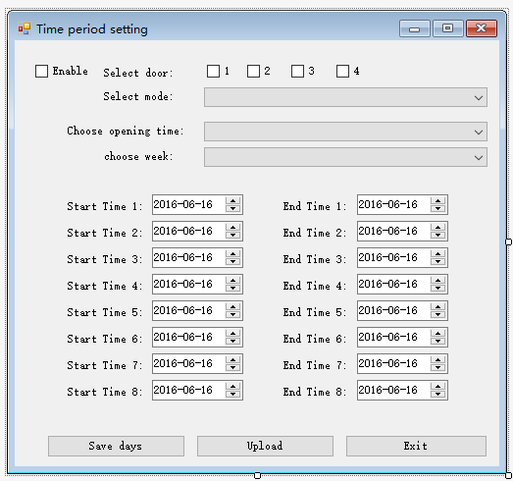
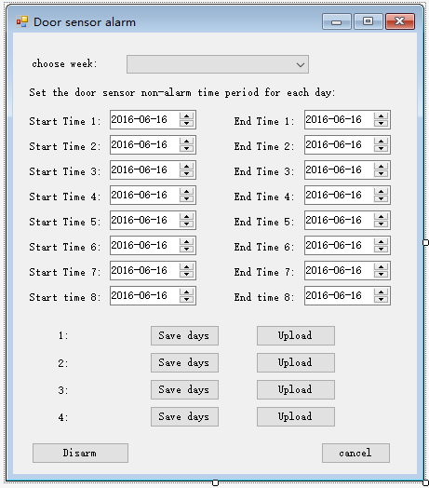
If not set the time zone for everyday, the default time zone is 00:00 to 23:59;

- Since the search function and data monitoring function abandon the searchDev and realTimeMonitor interfaces; please quote FCardCDrive.dll to the project and add the corresponding using:

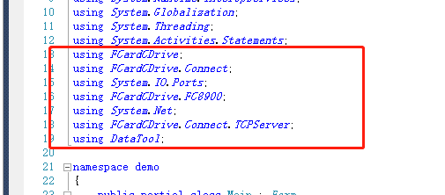

Form1_Load must add:

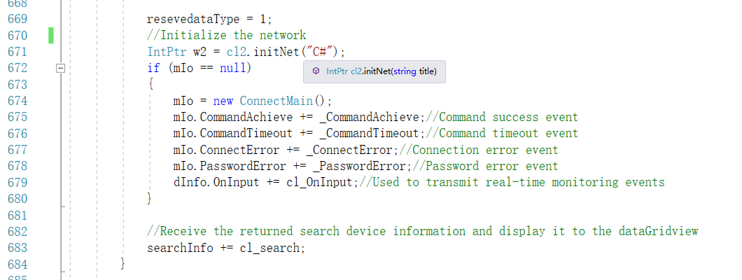
Define mIO in the real-time monitoring class as a global variable to facilitate remote door opening calls:
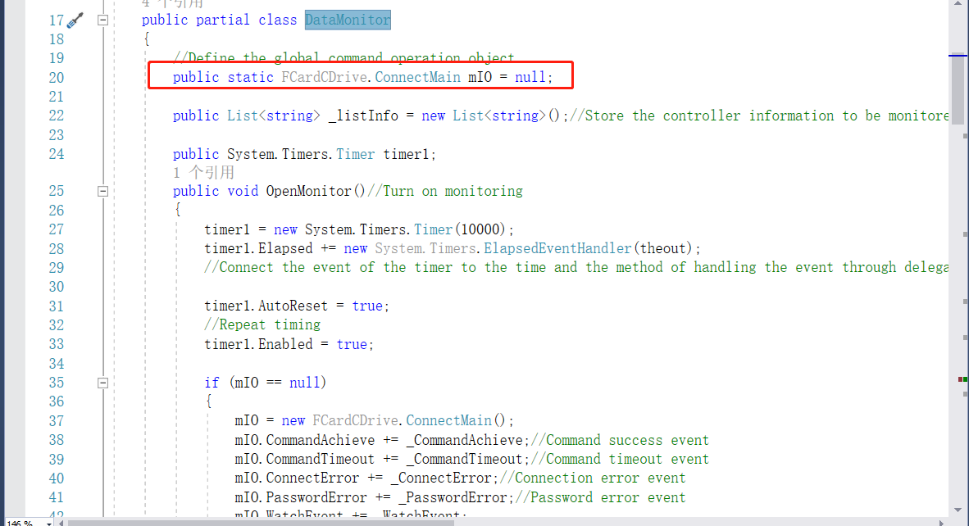
For the specific usage process, please refer to our written search and data monitoring functions

7. Remote open door

please quote FCardCDrive.dll to the project and add the corresponding using:

using FCardCDrive;
using FCardCDrive.Connect;
using System.IO.Ports;
using FCardCDrive.FC8900;
using System.Net;
using FCardCDrive.Connect.TCPServer;

Double-click the remote door open button on the main interface and add the following content:
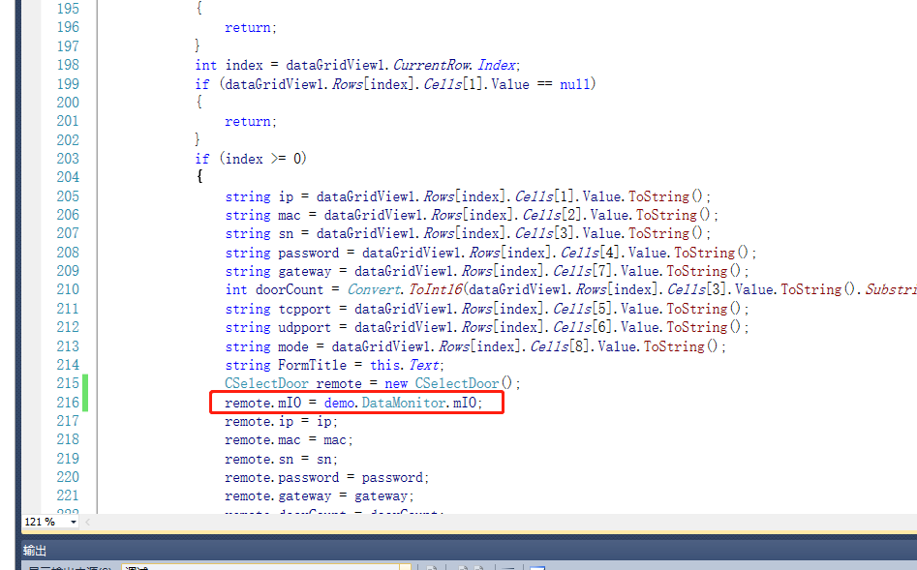
Used to realize remote door opening under real-time monitoring;
For the detailed code of remote door opening, please refer to: CSelectDoor.cs

8. Read device status information:
The quoted content is the same as remote opening;
Double-click the button to get device status on the main interface:
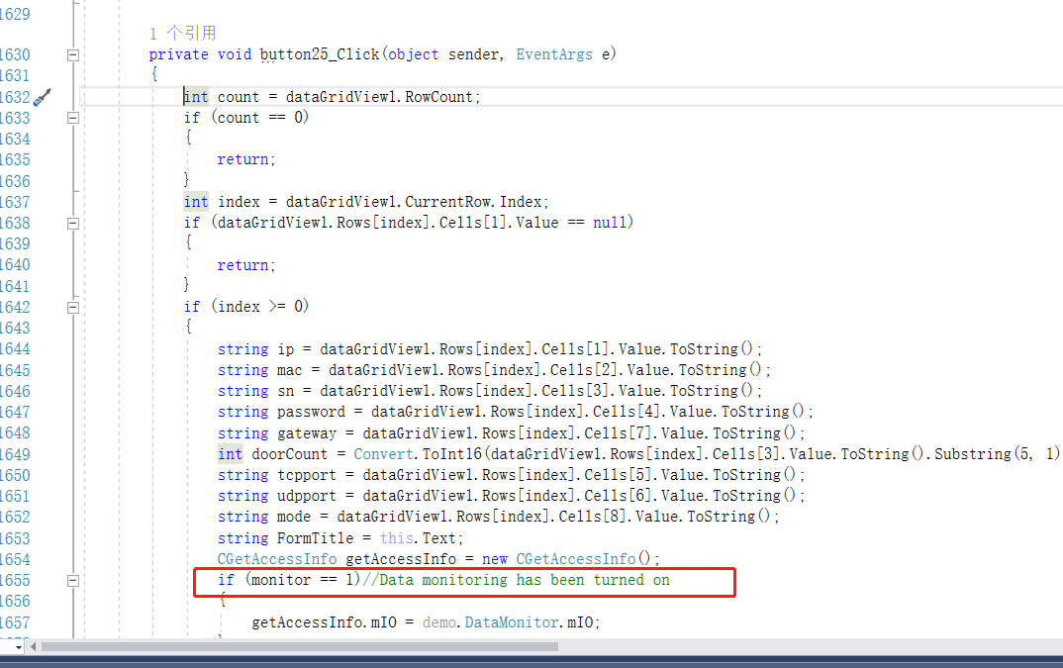
Please refer to the corresponding implementation method: CGetAccessInfo.cs
Click the button to get the door sensor status, and the return information is received by _CommandAchieve. It should be noted here that if data monitoring is enabled, it is received by_CommandAchieve in the real-time monitoring class DataMonitor.cs, normally it is received by _CommandAchieve in CGetAccessInfo.cs. :
